Experiment 8
FINAURA frontend improvements through software design principles
Original UI on the left and implemented live UI on the right. Screenshots use the same local test account and are cropped to the relevant workspace.

1 Overview
BEFORE ORIGINAL UI | AFTER UPDATED LIVE UI
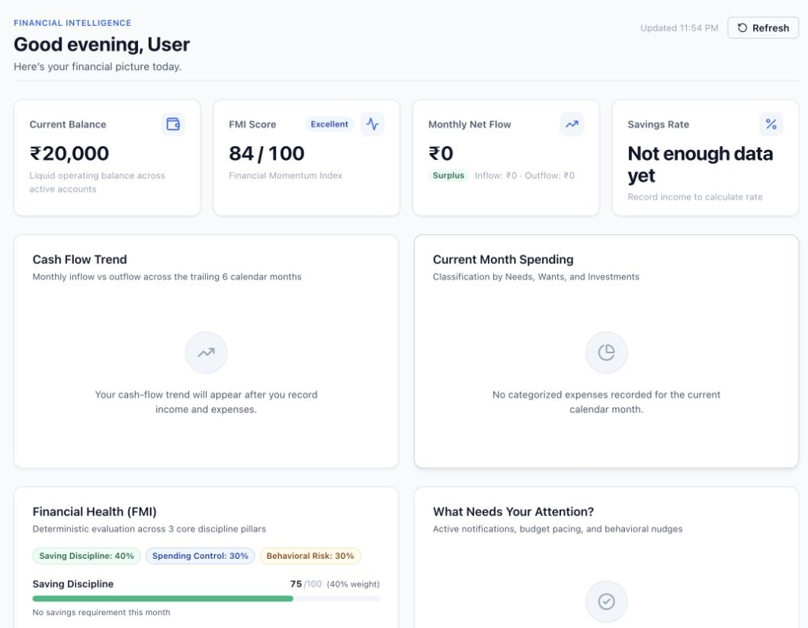 | 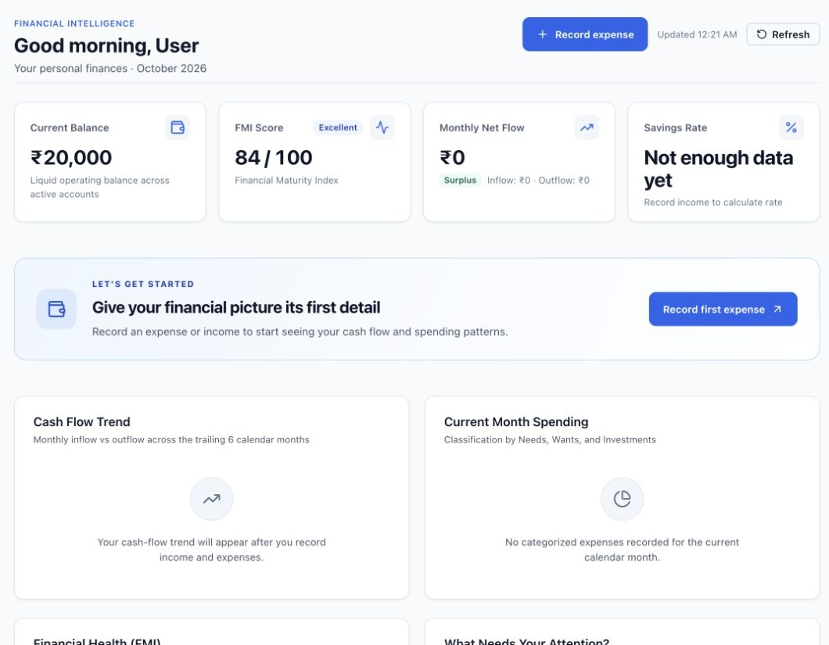

Before Large empty charts dominated the overview without a clear first action.
After A first expense panel and Record expense button guide the user; empty charts take less space.
Design principle Recognition and visual hierarchy make the next task obvious. A reusable NextStep component keeps first use guidance consistent.

2 Transactions
BEFORE ORIGINAL UI | AFTER UPDATED LIVE UI
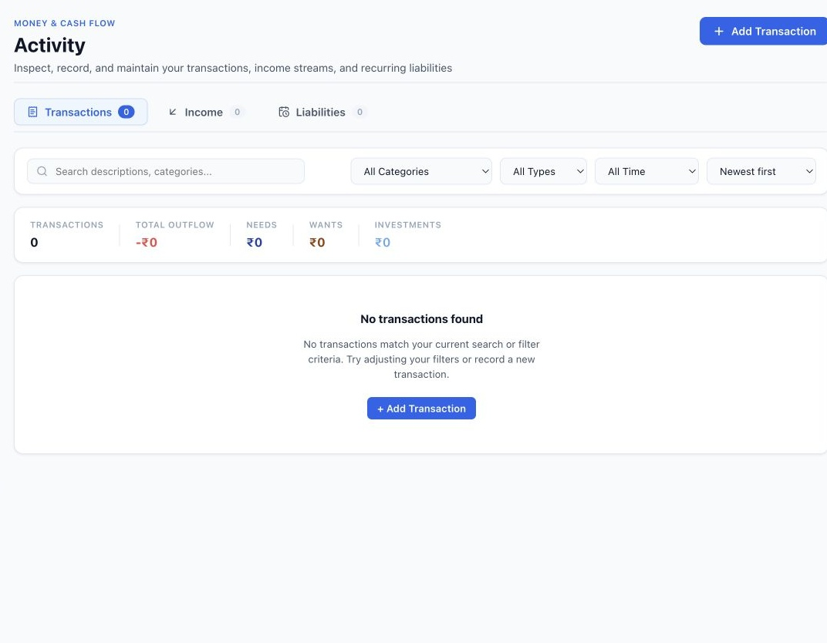 | 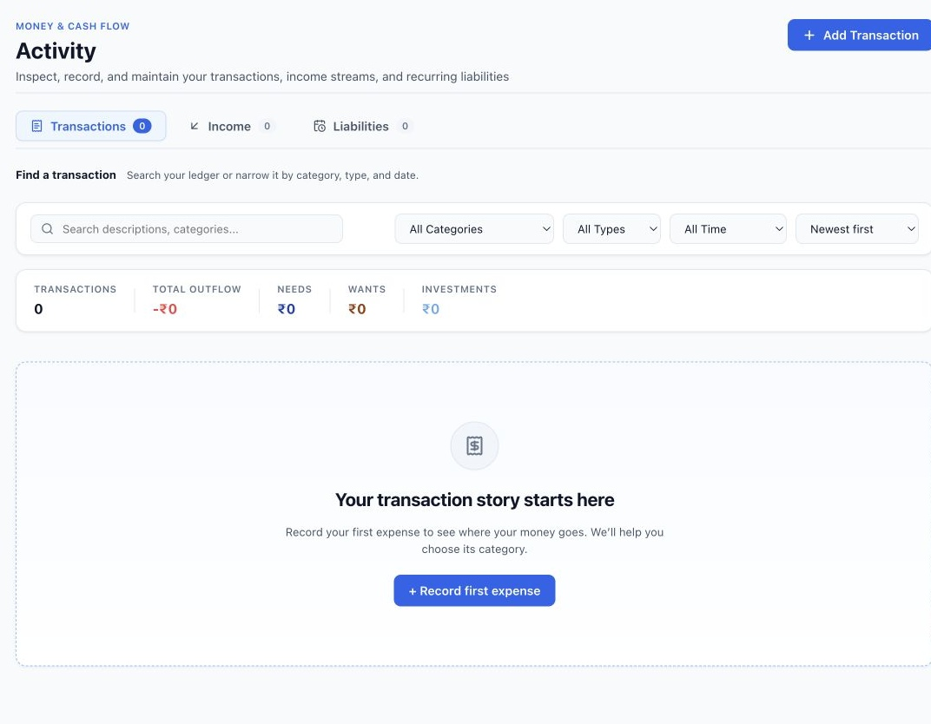

Before An empty account was described as having no transactions matching the filters.
After The empty ledger now explains how to begin and offers Record first expense. Filter guidance is explicit.
Design principle Visibility of system status distinguishes an empty ledger from a filtered search with no matches.

3 Expense entry
BEFORE ORIGINAL UI | AFTER UPDATED LIVE UI
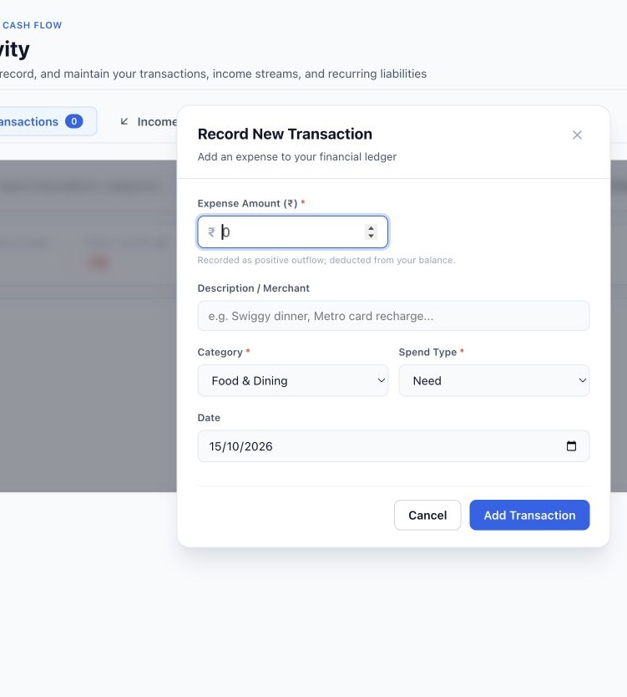 | 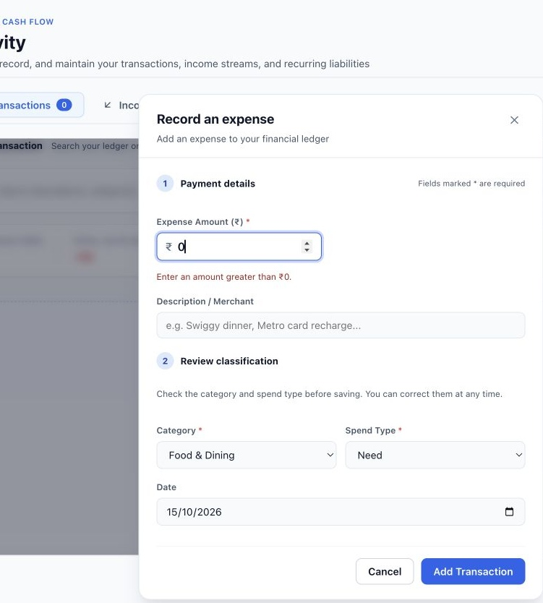

Before The form presented payment and classification fields without a clear review sequence.
After Numbered sections separate payment details from classification review. A zero amount shows an inline error.
Design principle Error prevention gives immediate, field specific feedback. Shared Input and Modal components encapsulate accessible error and keyboard behavior.

4 Behaviour insights
BEFORE ORIGINAL UI | AFTER UPDATED LIVE UI
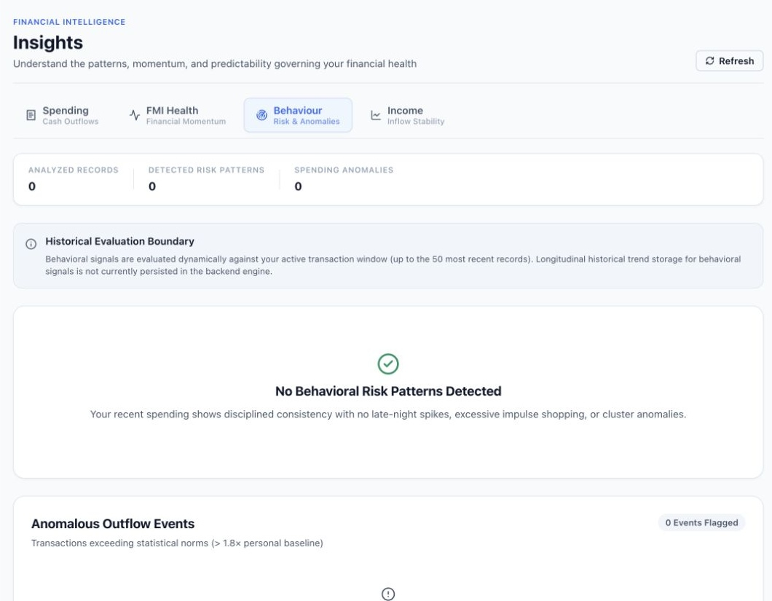 | 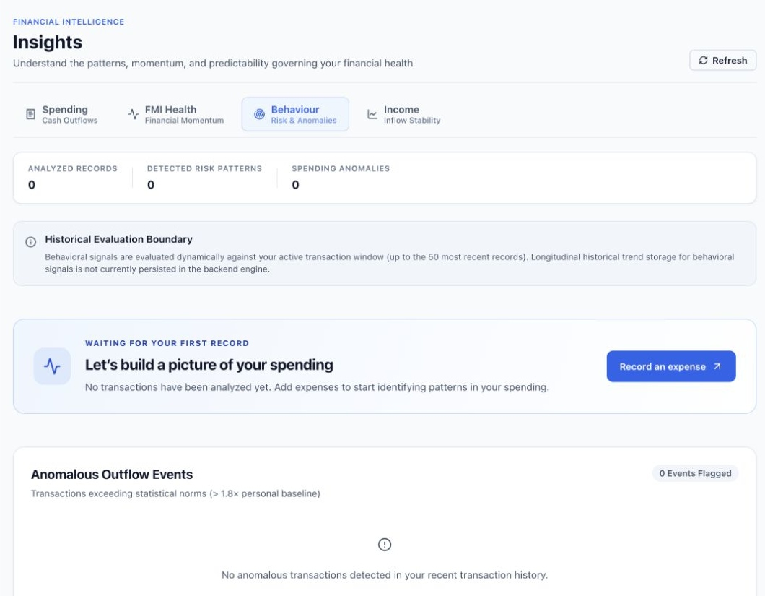

Before Positive spending messages appeared even though no transactions had been analyzed.
After A waiting for your first record state explains the missing evidence and links to expense entry.
Design principle Visibility of system status avoids presenting missing analysis as a positive conclusion.

5 Income insights
BEFORE ORIGINAL UI | AFTER UPDATED LIVE UI
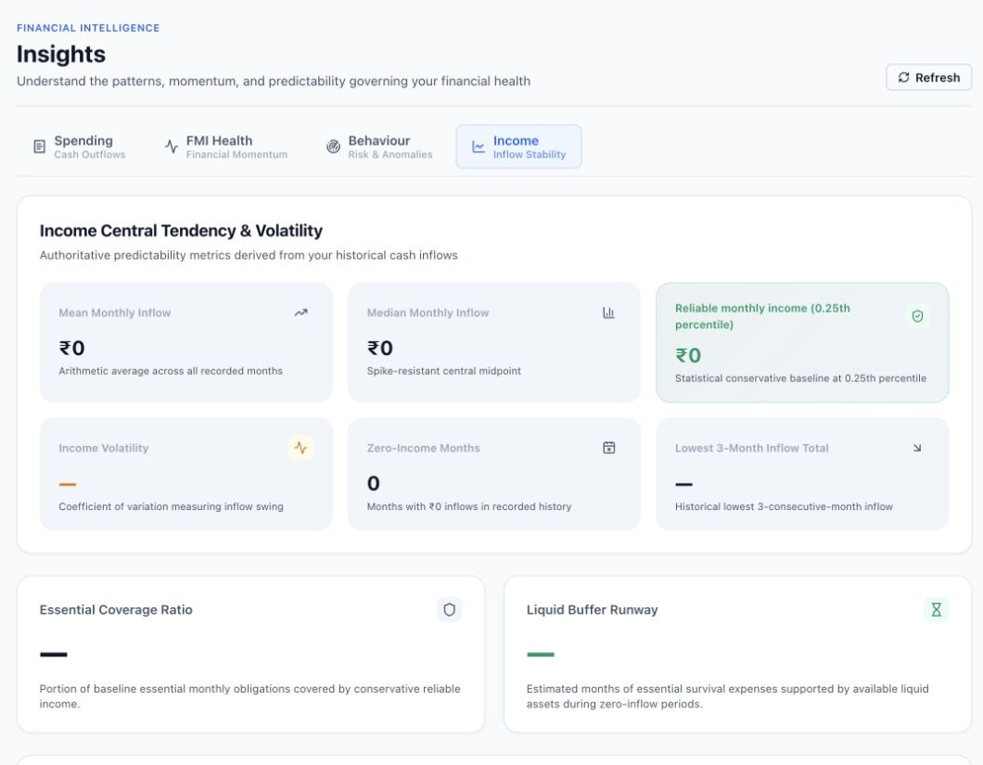 | 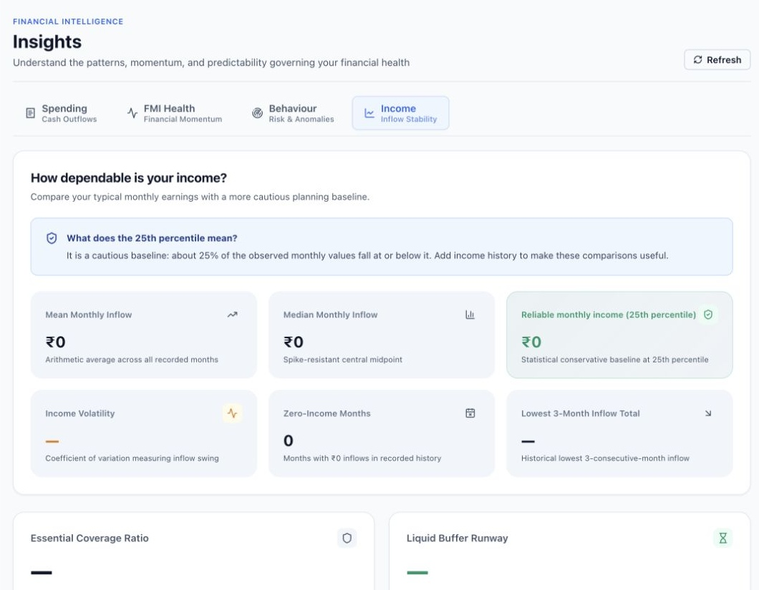

Before The safe income label displayed the fractional percentile as 0.25th percentile.
After The label shows 25th percentile and a short explanation describes what the figure means.
Design principle Abstraction normalizes the API fraction before display. Consistency and plain language keep the label and explanation aligned.

6 Retirement planning
BEFORE ORIGINAL UI | AFTER UPDATED LIVE UI
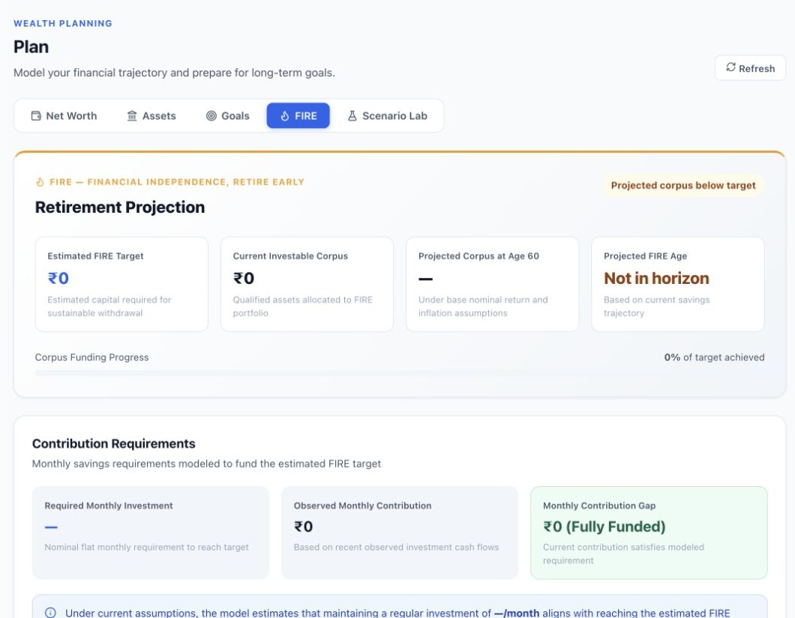 | 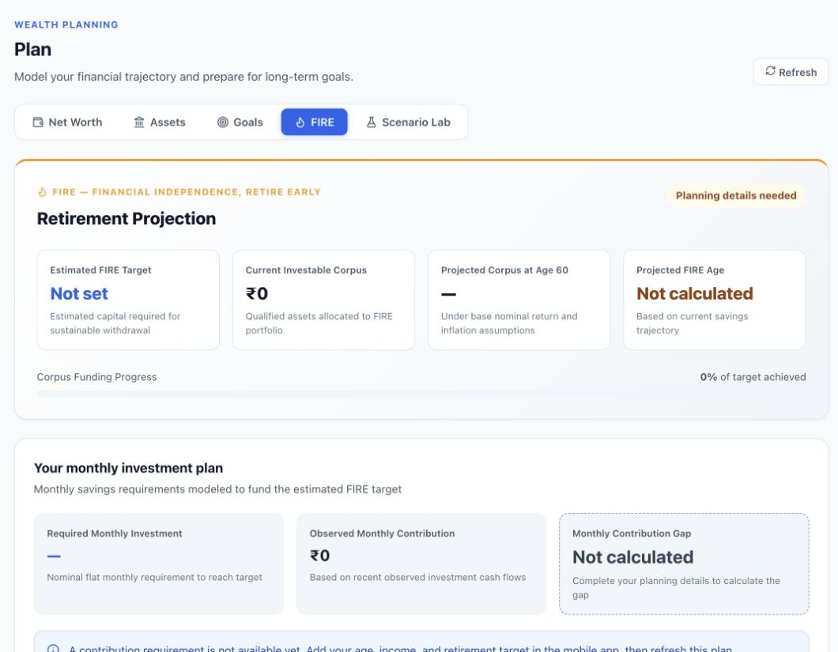

Before Missing planning inputs produced a Fully Funded contribution status and zero valued targets.
After Missing targets show Not set or Not calculated. The contribution panel requests the details needed for a calculation.
Design principle Explicit state modeling and error prevention separate unavailable calculations from a valid zero contribution gap.

7 Scenario inputs
BEFORE ORIGINAL UI | AFTER UPDATED LIVE UI
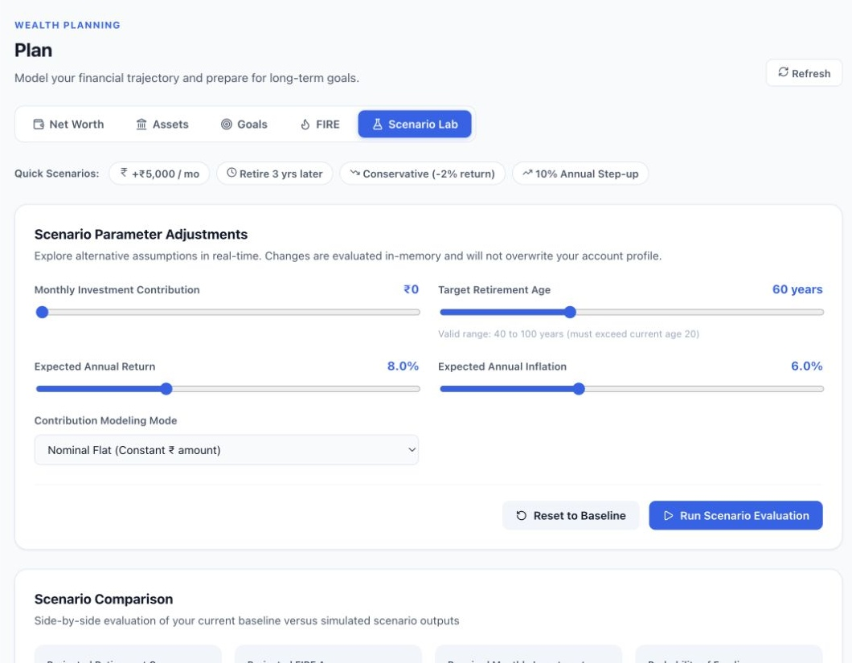 | 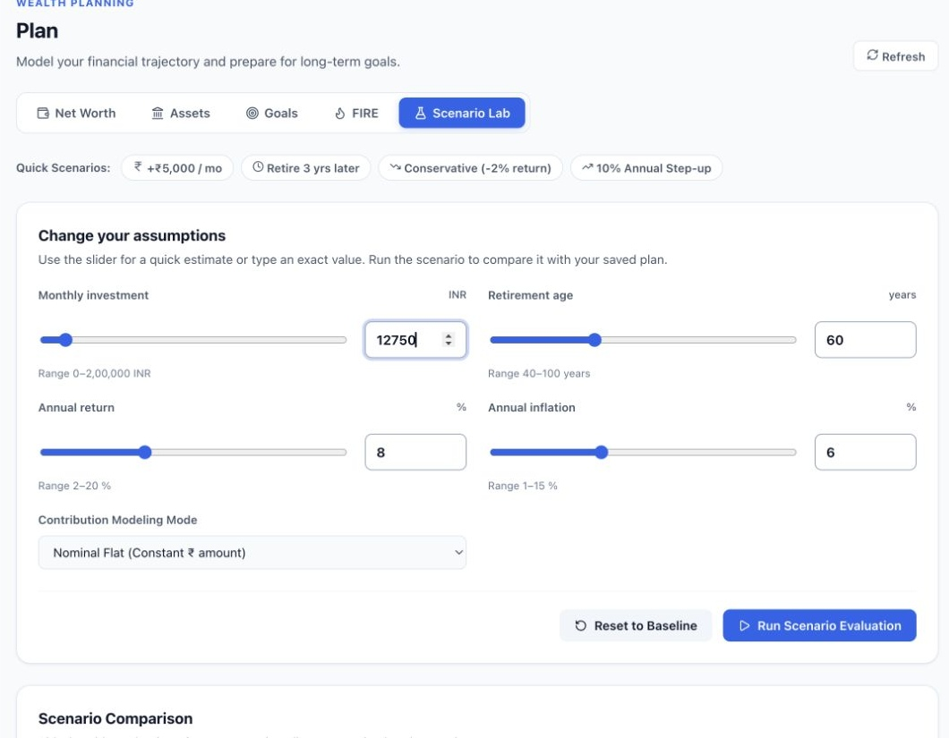

Before Sliders made precise assumptions difficult to enter and compare.
After Each main assumption pairs a slider with an exact numeric field. The monthly investment example is 12750.
Design principle User control supports both quick adjustment and precise entry. The reusable RangeField keeps values, bounds, labels, and validation together.

8 Report exports
BEFORE ORIGINAL UI | AFTER UPDATED LIVE UI
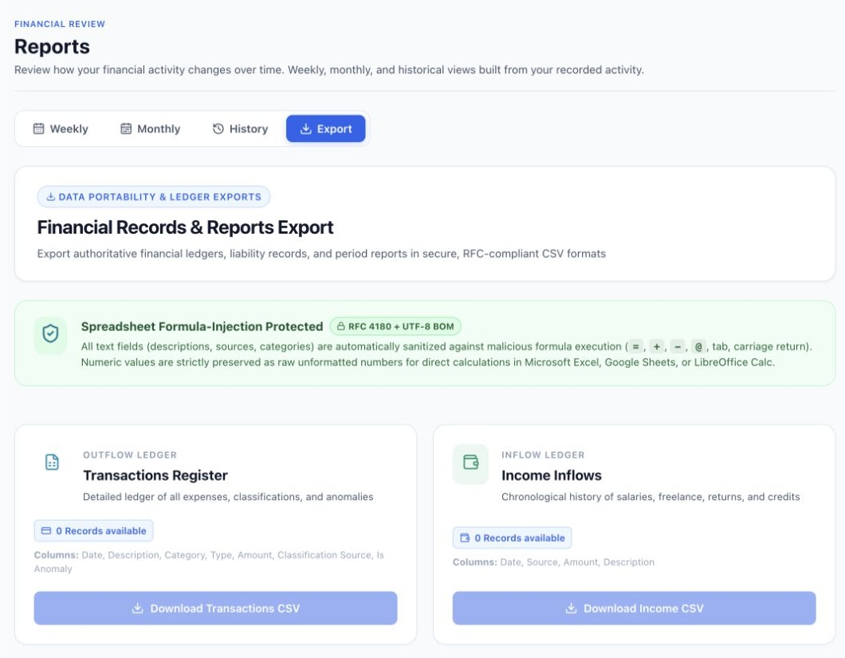 | 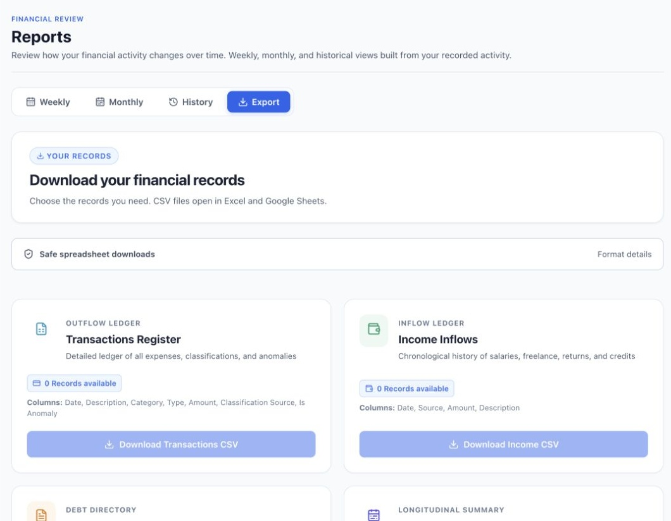

Before A large technical security explanation occupied space above the download choices.
After Download choices move higher. Format and spreadsheet safety details remain available in an expandable section.
Design principle Progressive disclosure prioritizes the main task while retaining supporting technical information.

9 Family setup
BEFORE ORIGINAL UI | AFTER UPDATED LIVE UI
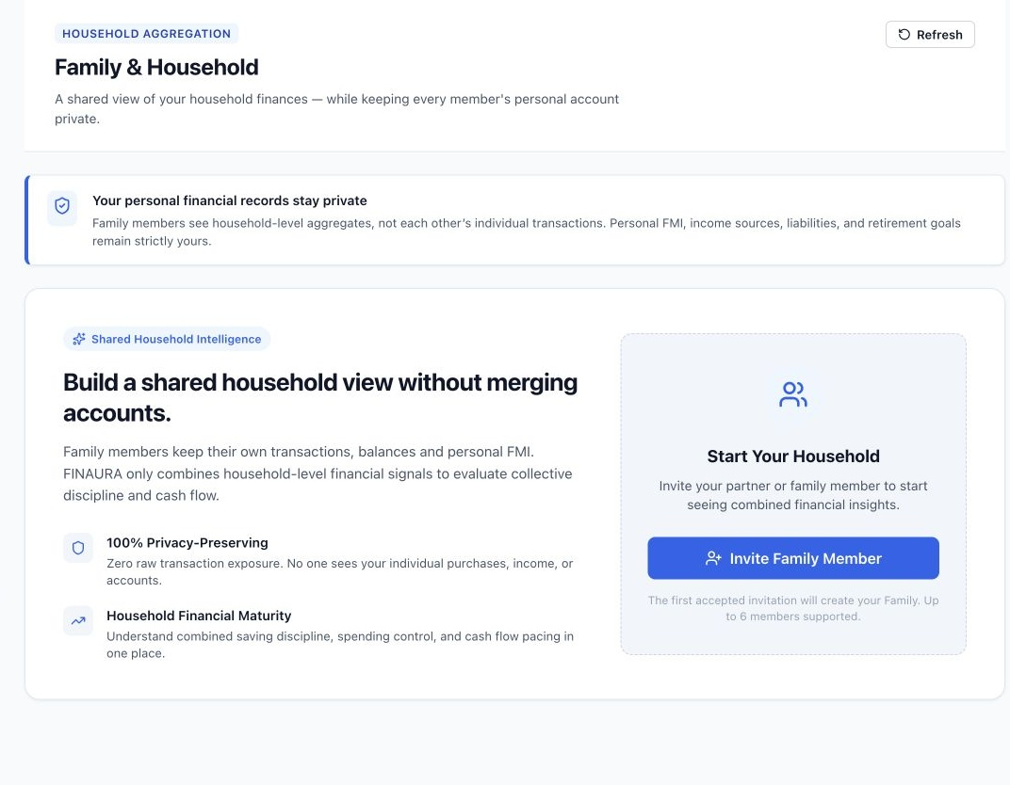 | 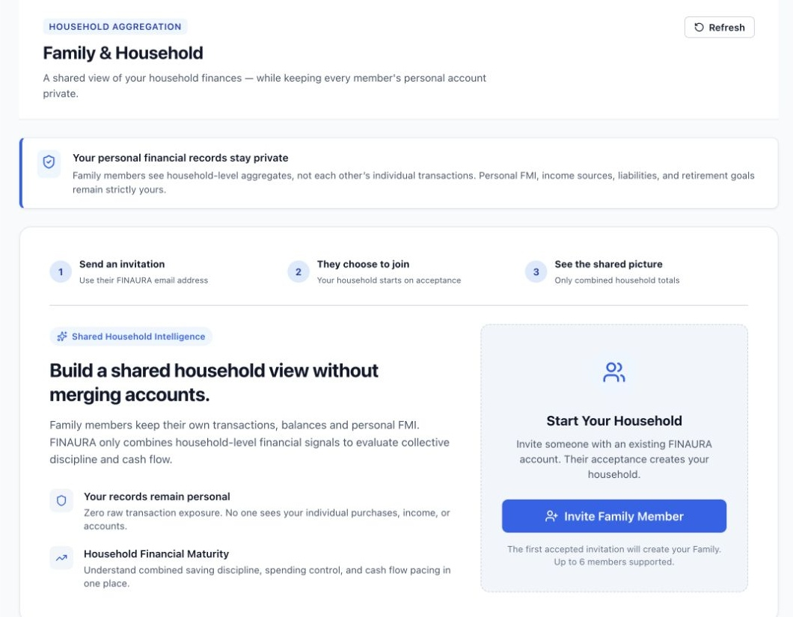

Before The setup card described household features without a visible invitation sequence.
After Three visible steps explain invitation, acceptance, and the shared household view.
Design principle Recognition reduces the need to infer the workflow. Clear sequencing explains what happens after an invitation.

10 Profile
BEFORE ORIGINAL UI | AFTER UPDATED LIVE UI
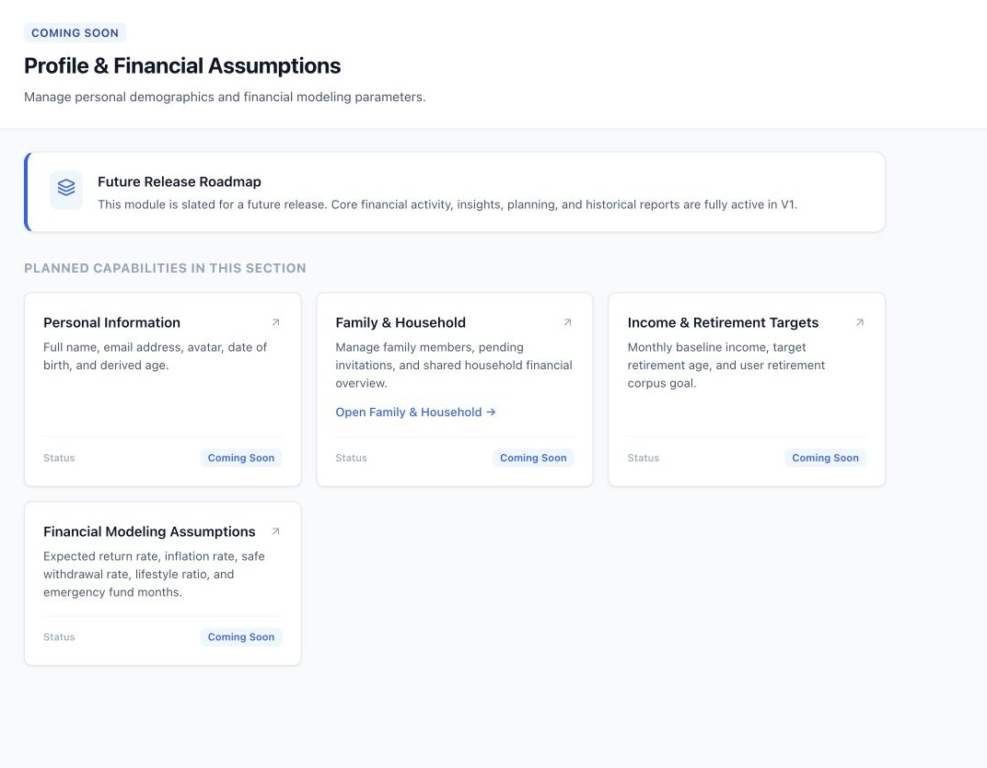 | 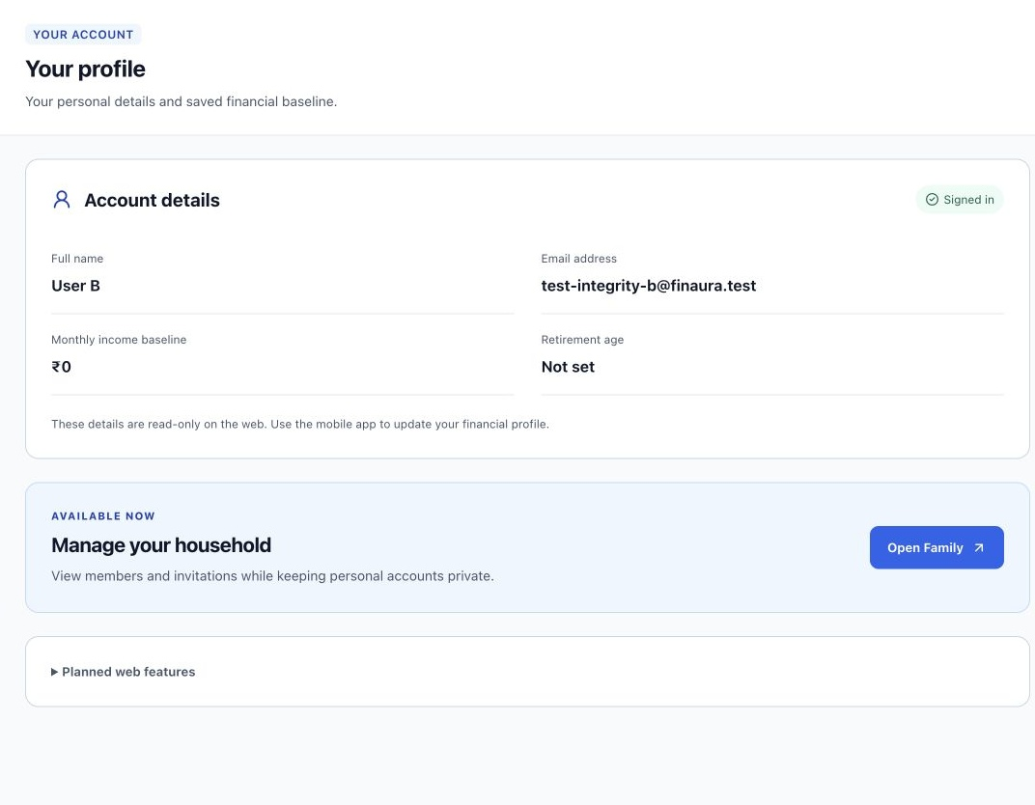

Before The profile route mainly displayed planned features and roadmap content.
After The page shows current account details and saved financial baseline, with a working Family shortcut. Future features are collapsed.
Design principle Visibility of system status exposes useful current information. Progressive disclosure gives planned features less prominence.

